**ASSIGNMENT NO 1**

**SUBMITTED BY:**

**RABEEA FATIMA  
REGISTRATION NO: 2023-BSE-049**

**SECTION: B  
SUBJECT: CLOUD COMPUTING**

**Task 1:**

Run Gitea in Codespace and Create an Initial Repo

1. Set up Gitea: - Run a Gitea server inside your Codespace. - Use HTTPS for communication (SSH is not supported in Codespace).

2. Create a Repository: - Create a new repository on your Gitea server. - Add a README.md file listing each student's name and roll number.

3. Add Remote Repo: - Use the following command to add your Gitea repository as a remote: git remote add gitea - Push your initial commit containing the README.md to Gitea

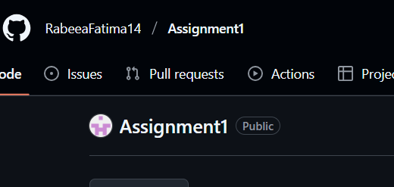

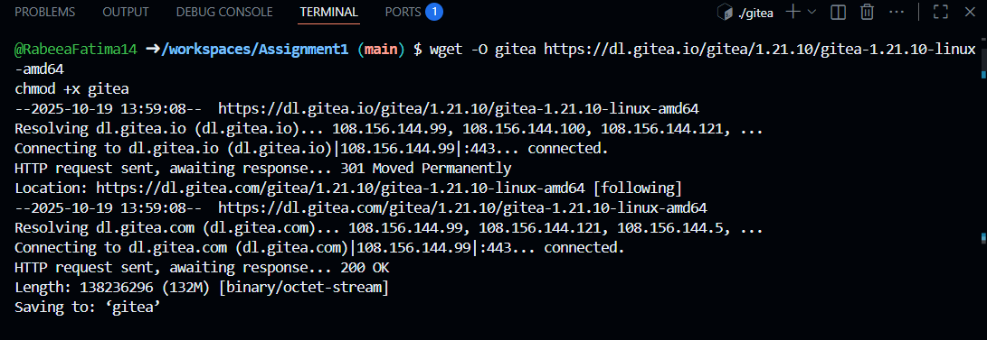

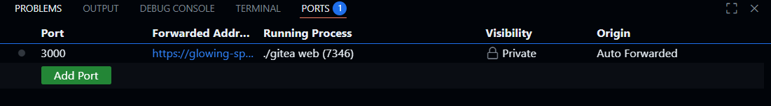

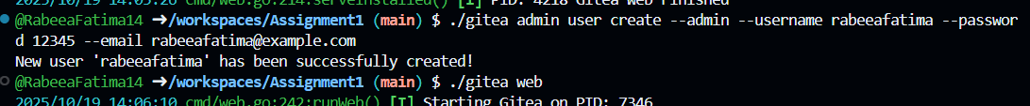

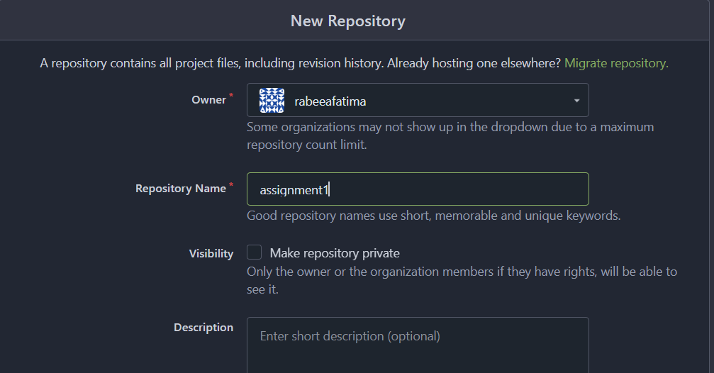

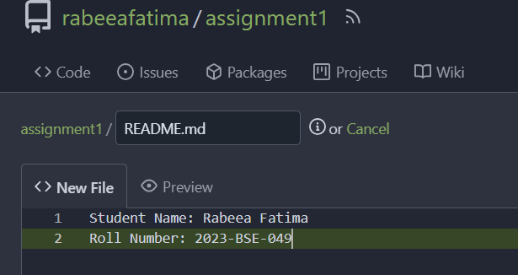

**Task 2:**

Mirror README.md from Gitea to GitHub

1. Continue Working with Your Existing Repository: - You will use the same repository that you created and pushed to your Gitea server in Task 1.

2. Create GitHub Repository: - Create a new GitHub repository named assignment 1.

3. Add GitHub as a Second Remote: - Add your GitHub repository as a remote to your local repository: git remote add github

4. Push the README.md File to GitHub: - Push the contents (including the README.md) from your local repository to GitHub.

5. Verify Remotes: - Run git remote -v and ensure both remotes (gitea and github) are listed.

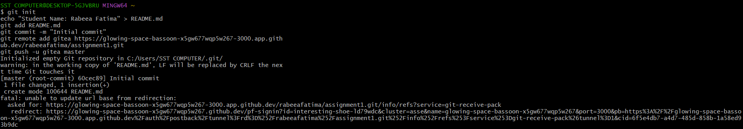

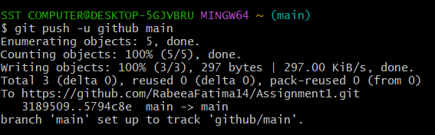

**Task 3:**

Use Git LFS for Large Files

1. Install Git LFS: - Set up Git LFS in your local repository.

2. Add Large Files: - Add three files larger than 100 MB each to your repository. - Track them using Git LFS: git lfs track "*.ext" - Replace .ext with the appropriate file extension.

3. Reference in Assignment Repo: - Commit and push these large files to your GitHub assignment 1 repo. - Ensure the files are referenced correctly in your repository history.

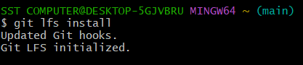

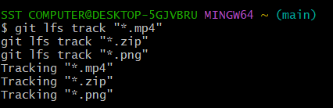  
  
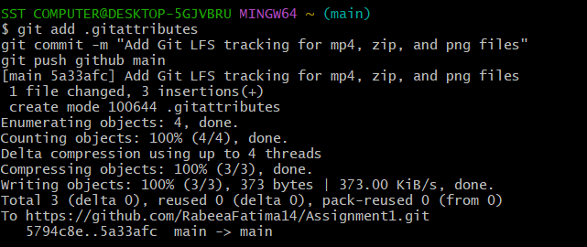

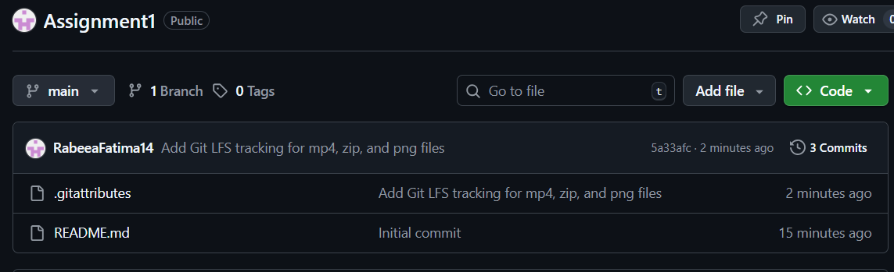

**Task 4:**

Create a Portfolio/CV with GitHub Pages

1. Create a new repository for GitHub Pages: - Create a new repository named .github.io. - Replace with your actual GitHub username (e.g., johnsmith.github.io).

2. Design Your Portfolio/CV: - Create your portfolio or CV in HTML/CSS (or use a static site generator).

3. Publish with GitHub Pages: - Push your portfolio/CV files to the .github.io repository. - Enable GitHub Pages in your repository settings if not automatically enabled. - Publish your site and share the link.

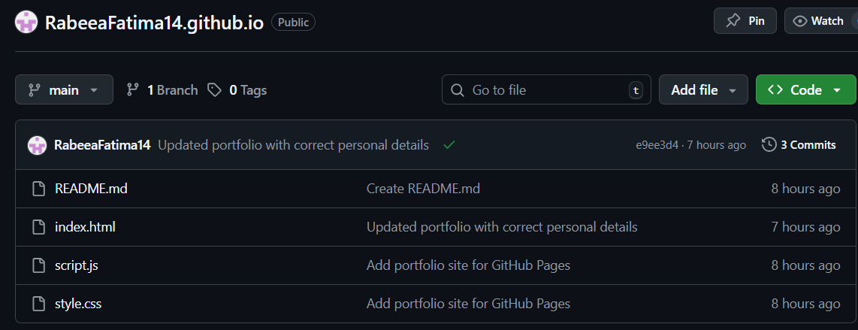

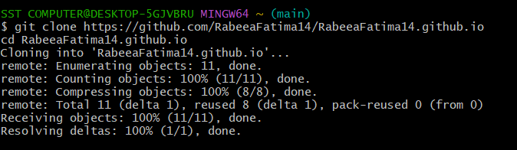

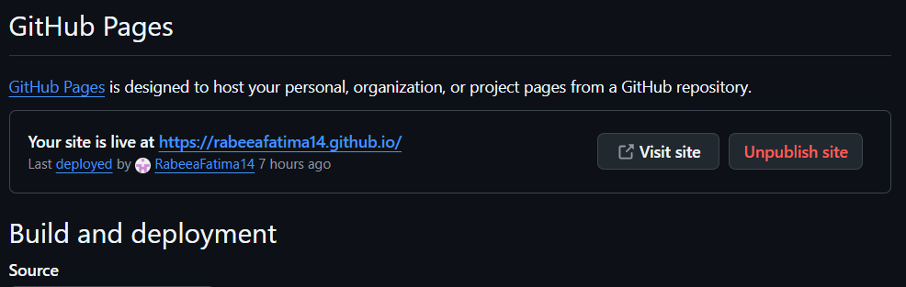

Link to the website.

<https://rabeeafatima14.github.io/>